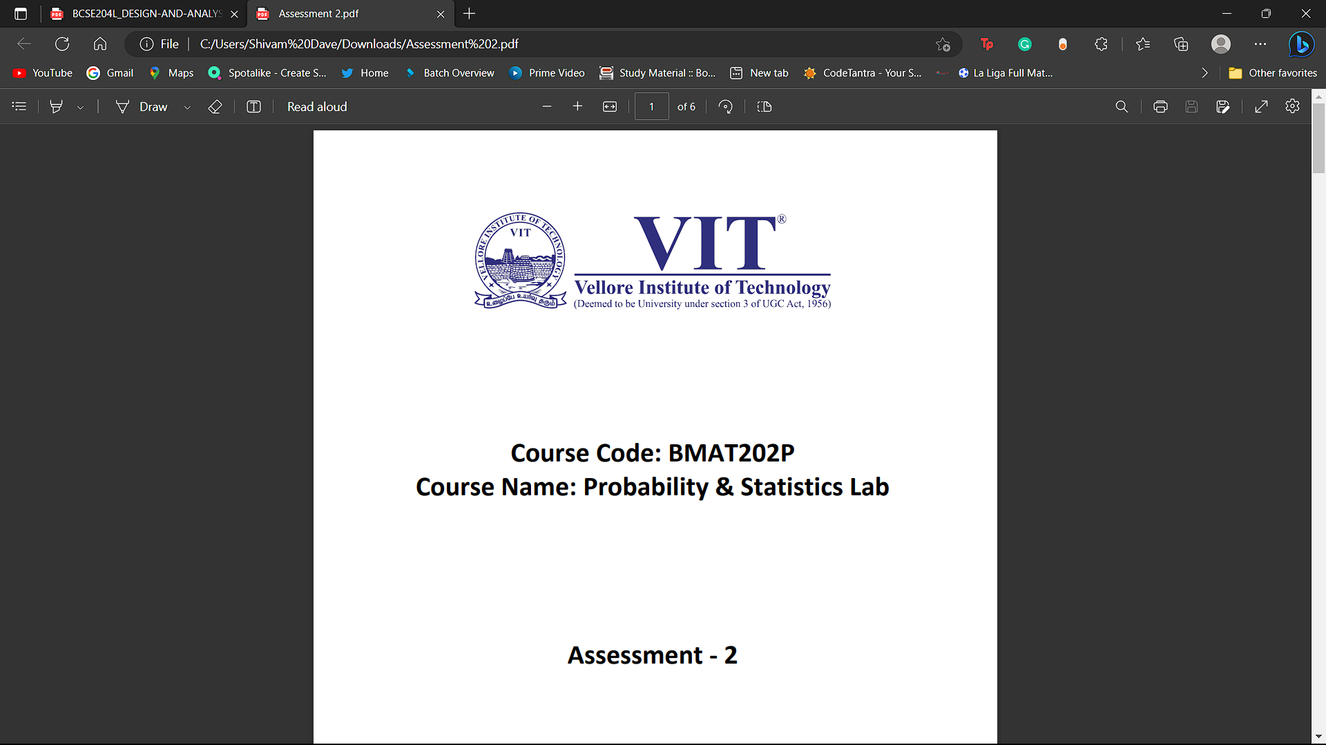

**Course Code: BCSE353E**

**Course Name: Information Security Analysis and Audit**

**Assessment – 2**

**Name: Shivam Dave**

**Reg. No.: 21BCB0107**

**Experiment 2: - DHCP Spoofing Attack Detection Explanation:**

Dynamic Host Configuration Protocol (DHCP) is a network protocol that is used to configure network devices to communicate on an IP network. A DHCP client uses the DHCP protocol to acquire configuration information, such as an IP address, a default route, and one or more DNS server addresses from a DHCP server.

DHCP spoofing occurs when an attacker attempts to respond to DHCP requests and trying to list itself (spoof) as the default gateway or DNS server, hence, initiating a man in the middle attack.

DHCP spoofing occurs when an attacker attempts to respond to DHCP requests and trying to list themselves (spoofs) as the default gateway or DNS server, hence, initiating a man in the middle attack.

With that, it is possible that they can intercept traffic from users before forwarding to the real gateway or perform DoS by flooding the real DHCP server with request to choke ip address resources.

4 steps of DHCP:

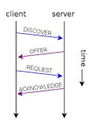

DHCP operations fall into four phases: server discovery, IP lease offer, IP lease request, and IP lease acknowledgement. These stages are often abbreviated as DORA for discovery, offer, request, and acknowledgement

**Problem Statement: -**

**Design a Network as shown below and show that there is a DHCP Spoofing in the designed network?**

**Your Network design should consist of 4 Servers (1- Organization Server, 1Attacker’s Server, 1-Original Google/Amazon Server and 1- Fake Server created by the attacker with similar ip address of the Original Server), and with other required Network Devices and Endpoints.**

**switches (2960)**

**Routers (2811)**

**Use the Network Commands using CLI options of the Cisco Packet Tracer.**

**Sample Network: DHCP Spoofing (**Screenshot**).**

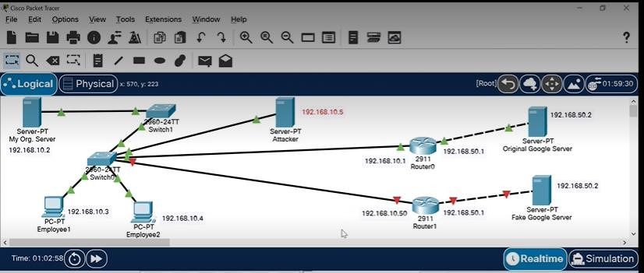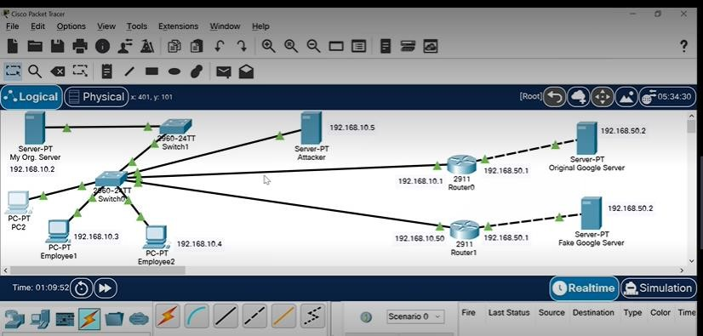

# **CIRCUIT->**

